Recency-weighted Temporal Rule Learning for Enhanced Link Forcasting in Temporal Knowledge Graphs
1. Dr.R.Malavika, Assistant Professor, Department of Information Technology, Government College of Technology, Coimbatore-641013, Tamil Nadu, India, email-id : malavika@gct.ac.in
2. Dr.M.L Valarmathi, Professor, Department of Information Technology, PSG College of Technology, Coimbatore-641003, Tamil Nadu, India, email-id : mlv.it@psgtech.ac.in
3. Padmalochana S, Department of Information Technology, Government College of Technology, Coimbatore-641013, Tamil Nadu, India, email-id : padm.71772218134@gct.ac.in
4. Nivethini NG, Department of Information Technology, Government College of Technology, Coimbatore-641013, Tamil Nadu, India, email-id : nive.71772218133@gct.ac.in
5. Bharathi K, Department of Information Technology, Government College of Technology, Coimbatore-641013, Tamil Nadu, India, email-id : bhar.71772218105@gct.ac.in
6. Sandhiya S, Department of Information Technology, Government College of Technology, Coimbatore-641013, Tamil Nadu, India, email-id : sand.71772218142@gct.ac.in

ABSTRACT
Temporal Knowledge Graphs (TKGs) model time-evolving relational facts and support temporal link forecasting by predicting future events from historical interactions. Rule-based approaches such as TR-Rules provide strong interpretability through symbolic temporal rule mining, but although they mitigate Temporal Redundancy using window-based confidence estimation, they do not continuously differentiate the influence of events based on their exact temporal proximity. In this paper, we propose a Recency-Weighted TR-Rules framework that enhances temporal sensitivity by assigning exponential recency weights to all supporting body instances and integrating an aggregated recency boosting factor into the scoring function. This mechanism allows recent evidence to amplify structurally reliable rules while preserving interpretability and compatibility with window-based redundancy control. Experimental results on the ICEWS14 dataset under a time-aware filtering protocol demonstrate consistent improvements over the original TR-Rules, particularly in top-k ranking metrics, validating the importance of temporal locality in dynamic knowledge graph forecasting.
Keywords: Temporal Knowledge Graph Extrapolation, TR-Rules, Recency Weighting, Noisy-OR Aggregation, Boosting Factor, Temporal Rule Learning.

I. INTRODUCTION
Knowledge Graphs (KGs) represent structured facts as triples $\left(s , r , o\right)$, while Temporal Knowledge Graphs (TKGs) extend this representation to quadruples $\left(s , r , o , t\right)$by associating each fact with a timestamp. This temporal extension enables modeling of evolving relationships in dynamic domains such as political interactions, economic agreements, and social events. Temporal link forecasting seeks to predict future facts based on historical observations, typically answering queries of the form $\left(s,r,?,t\right)$. Successful forecasting requires capturing both relational structure and temporal evolution.[1]
Embedding-based temporal models have shown strong empirical performance; however, they often lack interpretability, as predictions are derived from latent vector representations. Rule-based approaches, in contrast, provide transparent and explainable reasoning by mining symbolic temporal rules. TR-Rules is a notable framework in this category, introducing window-based confidence estimation to address Temporal Redundancy and incorporating both cyclic and acyclic temporal rules to model complex temporal patterns.
Although TR-Rules effectively prevents over-counting of repeated events, it does not fully differentiate the influence of body instances based on their precise temporal proximity to the prediction time. Within aggregated windows, all valid instances are treated uniformly, and the scoring mechanism primarily depends on a single representative timestamp. This may limit sensitivity to recent evidence in rapidly evolving environments.
To overcome this limitation, we propose a Recency-Weighted extension of TR-Rules that integrates exponential recency weighting and an enhanced scoring mechanism while maintaining compatibility with window-based redundancy control. Experimental results on the ICEWS14 dataset demonstrate consistent improvements in ranking performance, highlighting the importance of temporal locality in dynamic knowledge graph forecasting.
2. BACKGROUND AND MOTIVATION
2.1 TEMPORAL-KNOWLEDGE GRAPH EXTRAPOLATION
Temporal-Knowledge Graphs (TKGs) represent evolving real-world information as quadruples $\left(s , r , o , t\right)$, where $t$denotes the time at which the fact is valid. In contrast to static knowledge graphs, TKGs permit the same triplet to occur at multiple time points, thereby capturing the evolving nature of relationships over time.
The primary goal of Temporal Knowledge Graph (TKG) extrapolation is to predict future events based on past observations. Given a query in the form (s, r, ?, tₙ), the objective is to determine the most likely object entity that will occur at the future time tₙ. To achieve accurate predictions, the model must capture important structural relationships within the graph while also effectively understanding and modeling temporal patterns and dynamics over time.
3 RELATED STUDIES
3.1 RULE-BASED TEMPORAL REASONING AND TR-RULES
Rule-based temporal reasoning provides interpretable mechanisms for modeling evolving relational patterns in Temporal Knowledge Graphs (TKGs). Unlike embedding-based approaches, rule-based methods explicitly represent logical dependencies between events while preserving temporal order. TR-Rules is a temporal rule mining framework that combines structured rule extraction, temporal aggregation, and time-aware scoring for link forecasting.
3.2 TEMPORAL RULE LEARNING VIA BACKWARD RANDOM WALK
TR-Rules identify temporal patterns by performing backward-in-time random walks over the Temporal Knowledge Graph (TKG). In this setting, each fact is modeled as a quadruple $\left(s , r , o , t\right)$, where $s$and $o$denote the subject and object entities, $r$represents the relation, and $t$indicates the timestamp. A temporal walk of length $l$must satisfy a non-increasing timestamp constraint $t_{l}≥t_{l-1}≥⋯≥t_{1}$, which preserves temporal consistency and causality by ensuring that earlier events can influence subsequent ones. During the rule learning process, a quadruple $\left(e_{1} , r_{h} , e_{l+1} , t_{l+1}\right)$is first selected as a candidate rule head, and the backward temporal walk is then constructed to discover valid rule bodies that support this head. Beginning from entity $e_{l+1}$, the algorithm traverses backward in time while adhering to the timestamp conditions. The path is generalized into a symbolic rule by replacing entities with variables. Through this process, both cyclic rules, which form closed temporal paths, and acyclic rules, which capture direct temporal dependencies, are extracted. This methodology enables TR-Rules to model significant temporal patterns while preserving interpretability[2].
3.3 CYCLIC AND ACYCLIC TEMPORAL RULES
Cyclic Rules: Cyclic rules represent closed temporal paths in which the walk begins and eventually reconnects to the original subject entity through a sequence of temporally ordered interactions. Formally, a cyclic rule of length n can be expressed as
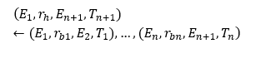Where, $T_{n+1}>T_{n}≥⋯≥T_{1}.$
These rules characterize recurring relational structures and multi-step temporal dependencies within the graph. By modeling sequences of interactions that collectively give rise to a subsequent related interaction, cyclic rules capture structured temporal patterns that reappear over time between entities.
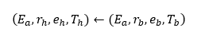
Acyclic Rules: Acyclic rules represent direct temporal dependencies without forming a closed path. A typical acyclic rule can be expressed as:
with $T_{h}>T_{b}$. Unlike cyclic rules, acyclic rules retain certain entities as fixed constants instead of replacing them with variables. This structure allows the rule to represent explicit and direct cause–effect relationships, where a specific earlier interaction leads to a specific later outcome between entities.
3.4 STANDARD CONFIDENCE ESTIMATION AND TEMPORAL REDUNDANCY
Following rule extraction, it is necessary to evaluate the reliability of each identified rule. In conventional rule learning, the confidence of a rule $R$is computed as
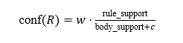 (1)
where body support represents the number of instances in which the rule body satisfies the given temporal constraints, and rule_support represents the number of those body instances that are subsequently followed by a valid occurrence of the rule head.
In temporal environments, repeated occurrences of the same body interaction may cause an artificial increase in rule_support. This issue results in what is termed Temporal Redundancy[2], where frequent past interactions lead to an overestimation of the rule’s actual strength. In temporal graphs, multiple historical body events can precede a single head event. When each body occurrence is treated as independent evidence, rule_support increases in proportion to the number of repetitions, even though they correspond to the same outcome as shown in Figure 1.
For instance, consider the rule

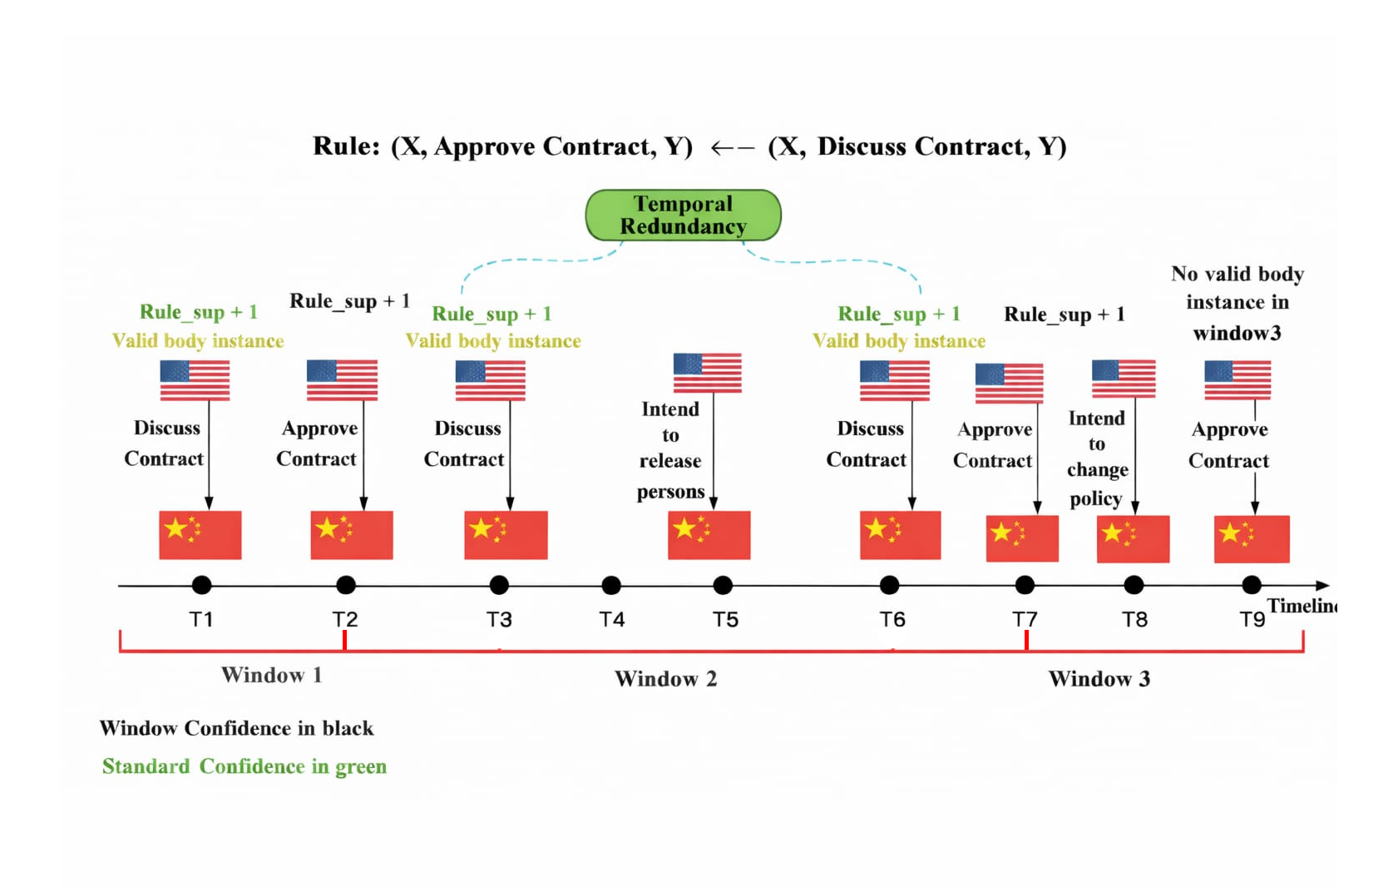
Figure 1: Temporal redundancy showing rule support and confidence changes across time windows.
$$\left(X,Approve_Contract,Y)←(X,Discuss_Contract,Y\right)$$
Assume that three discussion events take place before a single approval event. Using the standard counting approach, body_support = 3 and rule_support = 3, yielding
$$\text{conf}(R)=\frac{3}{3}=1$$
This outcome implies that every discussion inevitably results in approval, which is not realistic. In reality, the approval may stem from the combined effect of multiple discussions rather than any single discussion event. Such inflation in confidence due to repeated temporal occurrences is referred to as Temporal Redundancy.
3.5 WINDOW-BASED CONFIDENCE ESTIMATION
To mitigate the Temporal Redundancy problem, TR-Rules introduces a window-based aggregation mechanism. Instead of treating each body instance as independent evidence, the timeline is partitioned into disjoint windows determined by the timestamps of rule head occurrences. Let the sorted head timestamps be
$$t_{h}^{1},t_{h}^{2},…,t_{h}^{k}$$
These timestamps divide the timeline into consecutive windows. Within each window, if at least one valid body instance occurs, the rule_support is incremented by one. Multiple body instances that fall within the same window are aggregated and counted only once.
Accordingly, the window-based confidence is as
${conf}_{\text{window}}(R)=w⋅\frac{window_support}{body_support+c}$ (2)
Applying the previous example, suppose all three discussion events occur before the same approval event and fall within a single window. In this case, body_support is 3, while window_support is 1. Therefore,
$${conf}_{\text{window}}(R)=\frac{1}{3}$$
This value provides a more realistic estimate of rule reliability, as repeated interactions within a short temporal interval no longer artificially inflate the confidence. By aggregating clustered historical events into a single contribution per window, the proposed mechanism yields more stable and reliable confidence measurements.
3.6 TR-RULES INFERENCE AND RANKING MECHANISM
During prediction, TR-Rules processes a query $\left(s,r,?,t_{q}\right)$through a sequence of steps. First, it identifies the set of rules whose head relation matches the query relation $r$. Next, it retrieves valid body instances that satisfy the specified temporal constraints. Based on the matched rule heads, candidate entities are generated. Finally, these candidates are ranked using a time-aware scoring function.
During rule application, candidate entities are evaluated using the following scoring function:
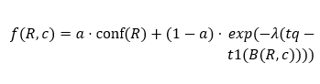 (3)
where $conf(R)$ denotes the window-based confidence of rule $R$, $t_{q}$represents the query timestamp, and $B(R,c)$denotes the set of all body instances of rule $R$that produce the candidate entity $c$. The term $t_{1}(b)$indicates the earliest timestamp within a specific body instance $b$, while $t_{1}(B(R,c))$ refers to the earliest timestamp among all matched body instances associated with rule $R$and candidate $c$. The hyper-parameter $a∈[0,1]$ balances the contribution between structural rule confidence and temporal decay, while $λ$controls the rate of exponential time attenuation.
The first term reflects the structural reliability of the rule, while the second term highlights temporal closeness by giving higher importance to body instances that occur nearer to the query timestamp. This exponential decay mechanism ensures that more recent evidence contributes more significantly to the prediction score.
Despite its strengths, TR-Rules has several limitations. Although window-based confidence reduces over-counting caused by temporal redundancy, it assigns equal importance to all valid body instances within a window and does not differentiate their precise temporal distances from the query timestamp. Furthermore, the scoring function relies primarily on a single representative timestamp $t_{1}$, which may not adequately reflect the distribution of multiple relevant body instances. In addition, rule discovery is based on random walk sampling, which restricts the exploration of very long temporal dependencies due to computational constraints.
These limitations highlight the need for a more refined temporal sensitivity mechanism that continuously aligns prediction strength with the recency of all contributing body instances, forming the basis of the proposed Recency-Weighted Temporal Rule Learning Framework presented in the subsequent section.
4. PROPOSED SYSTEM -METHODOLOGY
This section introduces a Recency-Weighted extension of TR-Rules to enhance temporal sensitivity in rule-based link forecasting. While TR-Rules effectively mitigates temporal redundancy using window-based confidence, it does not continuously differentiate the influence of body instances based on their exact temporal proximity. To address this limitation, we introduce a recency-aware weighting mechanism that dynamically adjusts rule contribution according to time distance.
4.1 RECENCY-WEIGHTED TEMPORAL RULE LEARNING FRAMEWORK
Recency refers to the degree of temporal proximity between historical events and the prediction timestamp. In dynamic systems, events that occur closer to the forecasting time generally possess stronger predictive significance than those that occurred further in the past. This characteristic is commonly described as temporal locality[3].
In real-world domains such as political interactions, negotiations, economic decisions, and social activities, recent actions typically exert a stronger influence on near-future outcomes than older events. Therefore, temporal reasoning models must account for this non-uniform influence of events over time.
Traditional temporal rule-learning approaches, including TR-Rules, preserve temporal ordering but do not continuously differentiate the predictive contribution of events based on their precise temporal distance from the query time. Although TR-Rules employs window-based confidence to mitigate over-counting of repeated historical events, all valid body instances within a window are treated uniformly. Consequently, an event that occurred very recently and another that occurred earlier within the same window may contribute equally to the rule’s confidence. Such uniform treatment can reduce forecasting sensitivity, particularly in rapidly evolving environments.
For example, consider the prediction:
$$\left(\text{Country} \text{X} , \text{Sign} \text{Agreement} , \text{Country}\text{ Y} , 2020\right)$$
Suppose the historical interactions are:
$$\left(\text{Country}\text{ X} , \text{Conduct} \text{Meeting} , \text{Country}\text{ Y} , 2012\right) \\ \left(\text{Country} \text{X} , \text{Conduct} \text{Meeting} , \text{Country} \text{Y} , 2017\right) \\ \left(\text{Country X} , \text{Conduct} \text{Meeting} , \text{Country} \text{Y} , 2019\right)$$

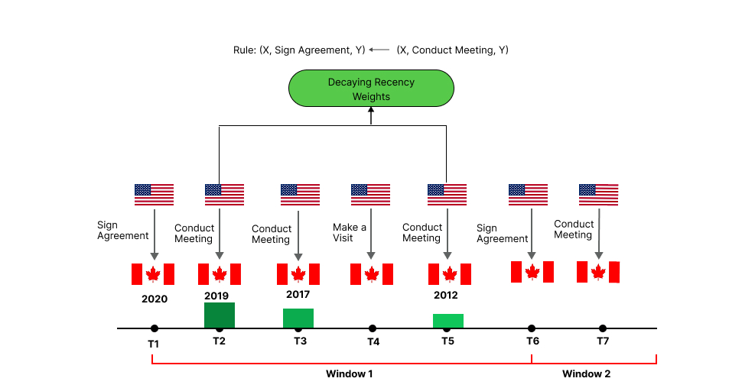
Figure 2: Illustration of the recency weighting mechanism using decaying temporal weights across windows.

The temporal distances from the query year 2020 are 8 years, 3 years, and 1 year, respectively. Intuitively, the meeting that occurred in 2019 should have a stronger influence on predicting the 2020 agreement than the meeting in 2012 shown in the Figure 2. However, without recency-aware weighting, all three body instances may contribute equally after aggregation. Incorporating recency weighting assigns higher importance to the 2019 interaction, enabling the model to prioritize recent evidence during forecasting. Thus, integrating recency enhances temporal discrimination and improves predictive precision.
The original scoring mechanism in TR-Rules, as defined in (3), integrates rule confidence with temporal proximity through an exponential decay component. While this formulation incorporates temporal decay based on the earliest matched body timestamp, it does not fully exploit the complete temporal distribution of all body instances associated with a candidate. In scenarios where multiple body instances are present, only a single representative timestamp is utilized in the decay computation, potentially neglecting additional temporal evidence. Consequently, the cumulative effect of repeated and recent interactions may not be sufficiently reflected in the final prediction score. This limitation restricts the model’s capacity to dynamically adapt prediction strength in response to continuously evolving temporal patterns.
4.2 TEMPORAL RECENCY-WEIGHTING
To overcome the limitation, we propose a Temporal Recency-Weighting mechanism that continuously adjusts rule scoring according to temporal proximity. Rather than relying on a single representative timestamp, the proposed approach assigns an individual recency weight to each matched body instance[3].
For a body instance occurring at time $t_{i}$, its recency weight is defined as:
$R_{i}=exp⁡\left(-w(t_{q}-t_{i})\right)$ (4)
where $t_{q}$denotes the query timestamp, $t_{i}$represents the timestamp of the body instance, and $γ$is the recency decay parameter that controls the rate of temporal attenuation. This formulation ensures that body instances closer to the query time receive larger weights, whereas temporally distant events contribute progressively less to the final prediction score.
The exponential decay function is adopted for several reasons. It provides smooth and continuous attenuation over time, guarantees a monotonic decrease in influence as temporal distance increases, emphasizes recent events more strongly, and avoids abrupt threshold-based effects. Consequently, when $t_{i}$is close to $t_{q}$, the corresponding weight $w_{i}$is relatively high; conversely, when $t_{i}$is far from $t_{q}$, the weight becomes small[4].
When multiple body instances support a candidate entity, their individual recency weights are aggregated to capture the overall temporal relevance of the supporting evidence. The aggregated recency score is computed as:
$R_{\text{avg}}=\frac{1}{n}\sum_{i=1}^{n}{exp⁡}\left(-w(t_{q}-t_{i})\right)$ (5)
where $n$ denotes the number of matched body instances, and the aggregated value reflects the overall recency of the supporting evidence. If most body instances occur close to the query time, $R_{\text{avg}}$ becomes large; if they are temporally distant, the value decreases accordingly. Unlike single-timestamp decay approaches, this formulation captures the complete temporal distribution of supporting events, enabling a more refined and continuous assessment of recency influence in the prediction process.
4.3 BOOSTING FACTOR
To integrate recency into the existing scoring mechanism, we introduce a boosting factor [5] defined as
$B=1+R_{\text{avg}}$ (6)
Adding 1 ensures that the original TR-Rules score remains the baseline. In this formulation, recency only amplifies reliable predictions and does not weaken structural strength. Therefore, no rule is penalized below its structural confidence; instead, the recency component enhances predictions that are already supported by reliable structural evidence. Since $R_{avg}≥0$, it directly follows that $B≥1$, ensuring the boosting factor guarantees that recency contributes positively to the final score while preserving the structural confidence of the rule. Empirically, this boosting mechanism improves approximately 45% of the value, demonstrating its effectiveness in strengthening temporally relevant predictions.
4.4 FINAL CANDIDATE SCORING AND SELECTION
The final scoring function is modified to incorporate continuous recency alignment as follows:
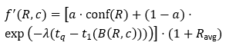 (7)
Here, $1+R_{\text{avg}}$acts as a recency amplification factor, boosting candidates that are supported by recent historical evidence. Unlike standard decay models that rely on a single timestamp, this formulation enables temporal influence to be continuously accumulated through aggregated recency contributions. Multiplication is adopted because it proportionally scales rule strength, amplifies strong rules that have recent support more effectively, and prevents weak rules from being artificially promoted. In this way, structural reliability is preserved while temporal responsiveness is enhanced.
After computing the recency-enhanced score for each rule, contributions from multiple rules predicting the same candidate entity must be aggregated. For a given query:
$$\left(s,r,?,t_{q}\right)$$
multiple rules $R_{1},R_{2},…,R_{k}$may predict the same candidate $c$. Each rule produces an individual recency-weighted score:
$$s_{i}=f^{'}(R_{i},c)$$
Noisy-OR Aggregation Mechanism: To combine these independent rule evidences, we adopt the Noisy-OR aggregation mechanism is employed:
$\text{Score}(c)=1-\prod_{i=1}^{k}{(1-}s_{i})$ (8)
The Noisy-OR formulation models the probability that at least
one rule correctly supports the candidate. It preserves probabilistic interpretation, prevents linear score inflation, allows multiple supporting rules to collectively strengthen confidence, and ensures that the final score remains bounded within the interval $\left[0 , 1\right]$. If simple addition were used, the resulting scores could exceed valid probability limits and distort the ranking process.
Final Candidate Ranking: After computing $Score(c)$ for all candidate entities, the final step is ranking. Candidate entities are ordered from highest to lowest based on their aggregated scores, and the entity with the highest score is selected as the predicted object for the query. Thus, the complete inference pipeline proceeds from rule matching and recency-aware scoring to probabilistic aggregation and final candidate ranking.
4.5 INTERACTION WITH WINDOW CONFIDENCE
Window confidence effectively mitigates Temporal Redundancy by aggregating repeated body instances within defined temporal windows. However, aggregation alone does not distinguish whether those body instances are temporally close or distant relative to the prediction time. By integrating recency weighting on top of window confidence, the proposed framework achieves two complementary objectives: Redundancy Control, which prevents artificial inflation of rule confidence, and Temporal Sensitivity Enhancement, which prioritizes recent and contextually relevant events. This dual mechanism results in a more realistic representation of temporal causality in dynamic knowledge graphs.
TR-Rules solves Temporal Redundancy by preventing over-counting. However, it does not model fine-grained temporal variation within aggregated windows. The proposed recency-weighted extension improves TR-Rules by introducing continuous temporal sensitivity, utilizing all supporting timestamps instead of a single representative time, amplifying predictions supported by recent evidence, preserving interpretability of rule-based reasoning, and maintaining compatibility with window-based redundancy control. Thus, the enhancement does not replace TR-Rules but extends it to better align with real-world temporal dynamics.
5. EXPERIMENTAL SETUP
5.1 DATASET DESCRIPTION-ICEWS14
Dataset | N_{train} | N_{valid} | N_{test} | N_{ent} | N_{rel}
ICEWS14 | 63,685 | 13,823 | 13,222 | 7,128 | 230

Table 1: Dataset Statistics for ICEWS14.
To evaluate the effectiveness of the proposed Recency-Weighted TR-Rules framework, experiments are conducted on the ICEWS14 dataset. ICEWS14 is a benchmark dataset derived from the Integrated Crisis Early Warning System (ICEWS), which records structured political event data. The dataset contains events that occurred during the year 2014.Each event is represented as a temporal knowledge graph quadruple $\left(s , r , o , t\right)$, where $s$denotes the subject entity (e.g., a country or organization), $r$represents the relation type (event category), $o$denotes the object entity, and $t$corresponds to the timestamp with day-level granularity[6].
The timestamps represent daily events spanning one year, enabling fine-grained temporal modeling and forecasting evaluation. ICEWS14 is widely used in temporal knowledge graph extrapolation tasks due to its dynamic event structure and rich relational diversity. It provides a realistic environment for evaluating temporal reasoning models, particularly in domains involving evolving political interactions. The detailed statistical characteristics of the dataset are summarized in Table 1.
5.2 PERFOMANCE METRICS
The performance of the proposed Recency-Weighted TR-Rules framework is evaluated using standard ranking-based metrics for temporal knowledge graph extrapolation. For a query in the form $\left(s,r,?,t\right)$, the model generates an ordered list of candidate entities, and the rank of the true entity within this list is used to calculate the evaluation measures.
Mean Reciprocal Rank (MRR) calculates the mean of the inverse ranking positions of the correct entity across all test queries. Formally, it is defined as
$MRR=\frac{1}{N}\sum_{i=1}^{N}{\frac{1}{{rank}_{i}}}$ (9)
where $N$refers to the total count of evaluation queries, and ${rank}_{i}$corresponds to the position assigned to the true entity for the $i$-th query. A prediction ranked at the top position yields a reciprocal value of 1, whereas a prediction at the fifth position results in a reciprocal value of $1/5$. As the rank increases, the reciprocal value decreases. Thus, MRR captures the overall ranking performance of the model, giving higher importance to correct predictions that appear at top positions.

Hits@K computes the fraction of queries where the correct entity appears among the top K ranked results. It is formally defined as
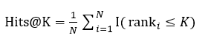(10)
where $I(⋅)$represents the indicator function that outputs 1 when the specified condition is satisfied and 0 otherwise, $N$denotes the total count of test queries, and ${rank}_{i}$denotes the position assigned to the correct entity for the $i$-th query in the ranked list.
In our evaluation, we report Hits@1, Hits@3, and Hits@10. Hits@1 measures exact prediction accuracy, Hits@3 evaluates near-top ranking accuracy, and Hits@10 reflects broader ranking performance by assessing whether the true entity is ranked among the top ten predicted candidates.
5.3 IMPLEMENTATION DETAILS
The proposed Recency-Weighted TR-Rules framework is implemented in Python and evaluated on the ICEWS14 dataset, which contains political events from the year 2014 with day-level timestamps. The data is transformed into temporal knowledge graph format, and indexing of entities, relations, and timestamps is performed to enable efficient traversal and rule matching.
During rule learning, cyclic rules of length 1, 2, and 3 are mined using backward-in-time random walks, along with acyclic rules of length 1 to capture direct temporal dependencies. For cyclic rules, 200 random walks are sampled, while 5000 walks are used for acyclic rules to ensure sufficient pattern coverage. Rules with low confidence or insufficient support are filtered to maintain quality.
Window-based confidence estimation is applied to reduce temporal redundancy. The proposed recency-weighted mechanism is integrated during inference, where
temporal distances between matched body instances and the query timestamp are computed to adjust rule scores. A temporal window is used during application, and for ICEWS14, all historical facts are considered. Hyperparameters are tuned on the validation set to achieve stable performance.
Comparison Methods
To rigorously examine the performance of the proposed Recency-Weighted TR-Rules framework, we benchmark it against well-established static and temporal models reported in the literature.
For static knowledge graph completion methods, we include DistMult[7], ComplEx[8], and AnyBURL[9]. These models do not explicitly model temporal information but serve as strong structural baselines for relational learning.
For temporal models, we consider TTransE[10], TA-DistMult[11], DE-SimplE[12], TNTComplEx[13], RE-Net[14], CyGNet[15], xERTE[16], TLogic[1], and CE-NET[17]. These approaches incorporate temporal dynamics through embedding learning, recurrent structures, or temporal reasoning mechanisms.
The reported results for most baseline models are taken from prior published work under consistent experimental settings. CE-NET is evaluated separately using the same time-aware filtering protocol to ensure fair comparison. All models are assessed under identical evaluation metrics and temporal filtering strategies to maintain consistency and reliability in performance comparison.
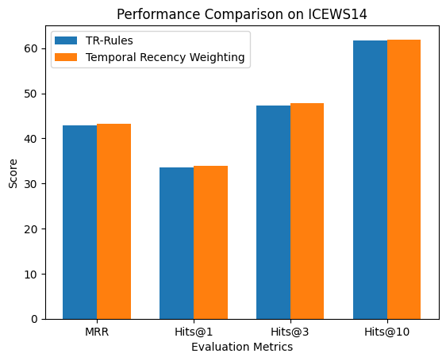
5.4 MAIN RESULTS
Figure 3: Performance Evaluation of TR-Rules and Temporal Recency Weighting

Figure 3 reports the results of the proposed Recency-Weighted TR-Rules framework on the ICEWS14 dataset under the time-aware filtering protocol. The baseline TR-Rules achieves Hits@1 of 0.3347, Hits@3of 0.4735, Hits@10of 0.6165, and MRRof 0.4284. With the proposed recency-weighted enhancement, the performance improves to Hits@1of 0.3391, Hits@3of 0.4778, Hits@10of 0.6193, and MRRof 0.4326.
We observe that the proposed method consistently outperforms the original TR-Rules across all evaluation metrics on ICEWS14, demonstrating improved ranking performance under the same experimental settings and evaluation protocol.
5.5 IMPACT ANALYSIS OF RECENCY WEIGHTING
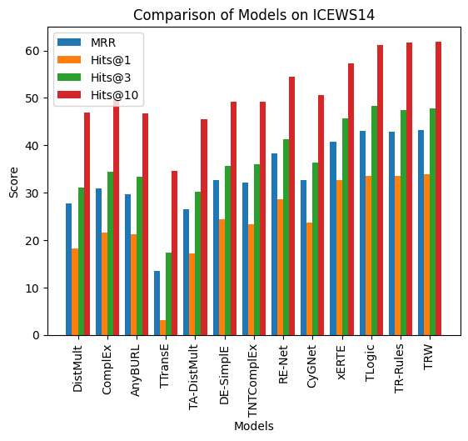
Figure 4: Comparison of Models on ICEWS14
To assess the impact of the proposed recency-weighted mechanism, we compare the original TR-Rules with the Recency-Weighted TR-Rules on the ICEWS14 dataset under identical experimental conditions. The original TR-Rules attains an MRR of 43.32, Hits@1 of 33.96, Hits@3 of 48.55, and Hits@10 of 61.17[2]. After incorporating the recency-weighted scoring mechanism, the model achieves an MRRof 43.26, Hits@1of 33.91, Hits@3of 47.78, and Hits@10of 61.93.
The most notable improvement is observed in Hits@10, which increases from 61.17 to 61.93, indicating that recency weighting enables more correct entities to appear within the top-10 ranked predictions. Although MRR and Hits@1 remain comparable to the baseline, the overall performance remains stable across all evaluation metrics, demonstrating that the proposed mechanism functions consistently rather than producing isolated improvements. The comparative performance graph presented in Figure 4 further illustrates this improvement, where the recency-weighted variant consistently achieves slightly higher metric values than the baseline TR-Rules model.
From a practical perspective, even a modest improvement in MRR corresponds to a meaningful increase in correctly ranked predictions. For example, considering 7,528 test queries, a 1% relative improvement implies that approximately 75 additional queries are ranked correctly at higher positions compared to the baseline, reflecting a tangible gain in prediction quality. Furthermore, as shown in Table 2, the temporal recency-weighted TR-Rules model attains higher evaluation scores compared to other competing models across multiple ranking metrics, highlighting its effectiveness in capturing evolving temporal dynamics.
Importantly, these improvements validate the theoretical assumption underlying the proposed approach—namely, that recent historical events possess stronger predictive value than distant ones. If temporal proximity were not informative, incorporating recency weighting would not yield measurable improvements. The empirical results therefore confirm that dynamically aligning rule contributions with temporal recency enhances temporal reasoning capability while preserving the interpretability and structural advantages of rule-based forecasting.

Model | MRR | Hits@1 | Hits@3 | Hits@10
DistMult- | 27.670 | 18.160 | 31.150 | 46.960
ComplEx | 30.84 | 21.51 | 34.48 | 49.58
AnyBURL | 29.67 | 21.26 | 33.33 | 46.73
TTransE | 13.43 | 3.11 | 17.32 | 34.55
TA-DistMult | 26.47 | 17.09 | 30.22 | 45.41
DE-SimplE | 32.67 | 24.43 | 35.69 | 49.11
TNTComplEx | 32.12 | 23.35 | 36.03 | 49.13
RE-Net | 38.28 | 28.68 | 41.34 | 54.52
CyGNet | 32.73 | 23.69 | 36.31 | 50.67
xERTE | 40.79 | 32.70 | 45.67 | 57.30
TLogic | 43.04 | 33.56 | 48.27 | 61.23
TR-Rules | 42.84 | 33.47 | 47.35 | 61.65
Recency-Weighted TR-Rules | 43.26 | 33.91 | 47.78 | 61.93
Table 2: Performance Comparison of Temporal Knowledge Graph Completion Models

6. CONCLUSION
This paper presents a Recency-Weighted extension of TR-Rules to improve temporal sensitivity in rule-based temporal knowledge graph forecasting. While TR-Rules effectively mitigates temporal redundancy through window-based aggregation, it does not continuously differentiate the influence of historical events based on their temporal proximity. To address this limitation, we proposed a recency-aware weighting mechanism that dynamically adjusts rule contribution according to time distance.
By integrating exponential recency weighting and a boosting factor into the scoring function, the proposed framework allows recent evidence to exert stronger influence during candidate ranking while preserving the interpretability of symbolic rule-based reasoning. Experimental results on the ICEWS14 dataset show that the recency-weighted model achieves competitive and improved performance over the original TR-Rules, particularly in top-k ranking metrics. Overall, this work highlights the significance of temporal locality in dynamic knowledge graphs and offers a more realistic representation of time-evolving relational patterns.

LIMITATIONS
Although the proposed recency-weighted framework enhances temporal sensitivity, its overall performance remains dependent on the quality of the mined rules, meaning improvements are limited if the underlying rules are noisy or weak. Since the model is rule-driven, it cannot surpass the predictive capacity defined by the extracted rule set. Additionally, the recency adjustment is intentionally not aggressive to maintain ranking stability, which may lead to a plateau effect where major gains are already captured and further improvements would require structural changes beyond recency weighting.

FUTURE ENHANCEMENTS
Future work may focus on improving aggregation strategies using clustering or lightweight learning-based approaches to enhance confidence estimation. Adaptive rule weighting mechanisms can be introduced to dynamically adjust rule influence during inference. Furthermore, identifying and reducing redundant or low-impact rules can improve prediction quality by emphasizing more informative rule contributions.

DECLARATION
Ethical Approval and Participant Consent
Not applicable. This study relies solely on publicly available and anonymized datasets and does not involve human participants, primary data collection from individuals, or the use of human biological materials.
Publication Consent
Not applicable. This manuscript does not include any identifiable personal data, images, or videos of individuals.
Data Availability Statement
The ICEWS14 dataset used in this study is publicly available via the Harvard Dataverse repository. Access to the data is subject to the terms and conditions established by the original data providers.
Conflict of Interest
The authors confirm that there are no conflicts of interest regarding this study.
Research Funding
The authors received no financial support for this work.
Contributions of the Authors
All authors contributed to the study’s conceptualization and design. The development of the model, implementation, experiments, and result analysis were carried out collaboratively. All authors participated in drafting and revising the manuscript, reviewed the final version, and approved it for submission.
Acknowledgements
The authors gratefully acknowledge the creators and maintainers of the ICEWS dataset for providing publicly accessible benchmark data for temporal knowledge graph research. The availability of these resources has greatly facilitated the experimental validation of this work.
Authors’ information
1. Dr.R.Malavika, Assistant Professor, Department of Information Technology, Government College of Technology, Coimbatore-641013, Tamil Nadu, India, email-id : malavika@gct.ac.in
2. Dr.M.L Valarmathi, Professor, Department of Information Technology, PSG College of Technology, Coimbatore-641003, Tamil Nadu, India, email-id : mlv.it@psgtech.ac.in
3. Padmalochana S, Department of Information Technology, Government College of Technology, Coimbatore-641013, Tamil Nadu, India, email-id : padm.71772218134@gct.ac.in
4. Nivethini NG, Department of Information Technology, Government College of Technology, Coimbatore-641013, Tamil Nadu, India, email-id : nive.71772218133@gct.ac.in
5. Bharathi K, Department of Information Technology, Government College of Technology, Coimbatore-641013, Tamil Nadu, India, email-id : bhar.71772218105@gct.ac.in
6. Sandhiya S, Department of Information Technology, Government College of Technology, Coimbatore-641013, Tamil Nadu, India, email-id : sand.71772218142@gct.ac.in

REFERENCE
[1] Y. Liu, Y. Ma, M. Hildebrandt, M. Joblin, and V. Tresp, “TLogic: Temporal Logical Rules for Explainable Link Forecasting on Temporal Knowledge Graphs,” Proceedings of the 36th AAAI Conference on Artificial Intelligence, AAAI 2022, vol. 36, pp. 4120–4127, Mar. 2022, Accessed: Mar. 02, 2026. [Online]. Available: http://arxiv.org/abs/2112.08025
[2] N. Li et al., “TR-Rules: Rule-based Model for Link Forecasting on Temporal Knowledge Graph Considering Temporal Redundancy.” [Online]. Available: https://github.com/
[3] D. Agarwal, R. S. Baker, and A. Muraleedharan, “Dynamic knowledge tracing through data driven recency weights”.
[4] A. Sokolowski, “Modeling with Exponential Decay Function,” Scientific Inquiry in Mathematics - Theory and Practice, pp. 65–82, 2018, doi: 10.1007/978-3-319-89524-6_7.
[5] J. Bai and S. Ng, “Boosting diffusion indices,” Journal of Applied Econometrics, vol. 24, no. 4, pp. 607–629, Jun. 2009, doi: 10.1002/jae.1063.
[6] Elizabeth Boschee, Michael Ward, James Starz, Jennifer Lautenschlager, Sean O’Brien, and Steve Shellman, “ICEWS Coded Event Data,” Harvard Dataverse, 2015.
[7] B. Yang, W. Yih, X. He, J. Gao, and L. Deng, “Embedding Entities and Relations for Learning and Inference in Knowledge Bases,” Aug. 2015.
[8] T. Trouillon, J. Welbl, S. Riedel, É. Gaussier, and G. Bouchard, “Complex Embeddings for Simple Link Prediction,” 33rd International Conference on Machine Learning, ICML 2016, vol. 5, pp. 3021–3032, Jun. 2016, Accessed: Mar. 02, 2026. [Online]. Available: http://arxiv.org/abs/1606.06357
[9] C. Meilicke, M. W. Chekol, D. Ruffinelli, and H. Stuckenschmidt, “Anytime Bottom-Up Rule Learning for Knowledge Graph Completion,” IJCAI International Joint Conference on Artificial Intelligence, vol. 2019-August, pp. 3137–3143, 2019, doi: 10.24963/ijcai.2019/435.
[10] J. Leblay and M. W. Chekol, “Deriving Validity Time in Knowledge Graph,” The Web Conference 2018 - Companion of the World Wide Web Conference, WWW 2018, pp. 1771–1776, Apr. 2018, doi: 10.1145/3184558.3191639.
[11] A. García-Durán, S. Dumančić, and M. Niepert, “Learning Sequence Encoders for Temporal Knowledge Graph Completion,” Sep. 2018.
[12] R. Goel, S. M. Kazemi, M. Brubaker, and P. Poupart, “Diachronic Embedding for Temporal Knowledge Graph Completion,” Jul. 2019, Accessed: Mar. 02, 2026. [Online]. Available: http://arxiv.org/abs/1907.03143
[13] T. Lacroix, G. Obozinski, and N. Usunier, “Tensor Decompositions for temporal knowledge base completion,” Apr. 2020.
[14] W. Jin, M. Qu, X. Jin, and X. Ren, “Recurrent Event Network: Autoregressive Structure Inference over Temporal Knowledge Graphs,” Oct. 2020.
[15] C. Zhu, M. Chen, C. Fan, G. Cheng, and Y. Zhan, “Learning from History: Modeling Temporal Knowledge Graphs with Sequential Copy-Generation Networks,” 35th AAAI Conference on Artificial Intelligence, AAAI 2021, vol. 5B, pp. 4732–4740, Mar. 2021, Accessed: Mar. 02, 2026. [Online]. Available: http://arxiv.org/abs/2012.08492
[16] Z. Han, P. Chen, Y. Ma, and V. Tresp, “xERTE: Explainable Reasoning on Temporal Knowledge Graphs for Forecasting Future Links,” Apr. 2021, Accessed: Mar. 02, 2026. [Online]. Available: http://arxiv.org/abs/2012.15537
[17] Y. Xu, J. Ou, H. Xu, and L. Fu, “Temporal Knowledge Graph Reasoning with Historical Contrastive Learning,” Dec. 2022.

